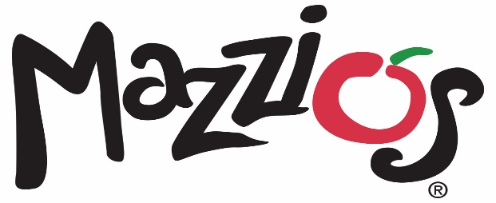

October 7, 2021

Contact: Kristy White (918) 638-0686

**Mazzio’s Kicks off its New Del City Location with Daily Specials Oct. 11-15**

Oklahoma-based Mazzio’s is opening its newest location in Del City at 4705 SE 29th St. with a week of specials during its official opening Oct. 11-15.

The grand opening week daily specials include:

* Monday, Oct. 11 - $6 Toasted Hoagie with Fries Special valid Monday for carryout only.
* Tuesday, Oct. 12 - $6 Chicken Alfredo Bake Special valid Tuesday for carryout only.
* Wednesday, Oct. 13 - $6 5-Piece Boneless Wings & Fries Combo Special valid Wednesday for carryout only.
* Thursday, Oct. 14 - $6 Calzone Ring Special valid Thursday for carryout only.
* Friday, Oct. 15 - $6 Large Pepperoni or Cheese Pizza.

The new Del City location will offer Mazzio’s full menu for carryout or delivery, and guests will have the chance to win free pizza for a year by signing up for the Mazzio’s Fresh Text Club by texting NEW to 644-444. Ten winners will be chosen on Oct. 15.

“We are excited to expand and open doors in Del City and showcase some of our special menu items,” said Lori Carver, CEO and president of Mazzio’s LLC. “Our Del City location is a strong addition to our system, and we look forward to opening additional units through increased franchising efforts in the future.”

Mazzio’s offers a full menu including signature pizza, pastas, hot sandwiches, world-famous Ranch dressing and Calzone Rings®. Del City will now be able to order Mazzio’s award-winning traditional and boneless wings with the choice of nine different flavors.

###

**About Mazzio’s LLC**

With 117 restaurants in 9 states, Tulsa-based Mazzio’s LLC was established in 1961 and is the parent company of the Mazzio’s Italian Eatery and Oliveto Italian Bistro brands. The company was founded in Tulsa, Oklahoma by the late Ken Selby and ownership remains in his family today.

Mazzio’s Italian Eatery’s 114 locations offer expedited service, convenience and great value in a fast casual setting. The family-friendly menu features Mazzio’s signature fresh salad bar and world-famous Ranch dressing, signature pizza, pastas, hot sandwiches, Wing Run® Wings and Calzone Rings® available for lunch and dinner, making it a perfect choice for dine-in, carryout, delivery, or large groups and catering.

To view our full menu, order online or get more information about Mazzio’s Italian Eatery, visit www.mazzios.com. Or download the Mazzio’s mobile app and enjoy ordering “on the go.”