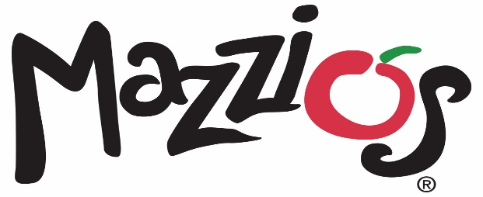

September 13, 2021

Contact: Kristy White (918) 638-0686

**Mazzio’s in Del City Now Open**

Oklahoma’s own Mazzio’s recently opened its newest location in Del City at 4705 SE 29th St.

The new Del City location will offer Mazzio’s full menu for carryout or delivery. As part of the location’s grand opening, Mazzio’s will offer guests the chance to win free pizza for a year. Guests can enter by signing up for the Mazzio’s Fresh Text Club by texting NEW to 644-444. Ten winners will be chosen in October.

“We are excited to expand and open doors in Del City,” said Lori Carver, CEO and president of Mazzio’s LLC. “The restaurant industry continues to evolve and we are excited to invest in a new business model that will elevate our brand to the next level of growth. Our Del City location is a strong addition to our system, and we look forward to opening additional units through increased franchising efforts in the future.”

Mazzio’s offers a full menu including signature pizza, pastas, hot sandwiches, world-famous Ranch dressing and Calzone Rings®. Del City will now be able to order Mazzio’s award-winning traditional and boneless wings with the choice of nine different flavors.

###

**About Mazzio’s LLC**

With 117 restaurants in 9 states, Tulsa-based Mazzio’s LLC was established in 1961 and is the parent company of the Mazzio’s Italian Eatery and Oliveto Italian Bistro brands. The company was founded in Tulsa, Oklahoma by the late Ken Selby and ownership remains in his family today.

Mazzio’s Italian Eatery’s 114 locations offer expedited service, convenience and great value in a fast casual setting. The family-friendly menu features Mazzio’s signature fresh salad bar and world-famous Ranch dressing, signature pizza, pastas, hot sandwiches, Wing Run® Wings and Calzone Rings® available for lunch and dinner, making it a perfect choice for dine-in, carryout, delivery, or large groups and catering.

To view our full menu, order online or get more information about Mazzio’s Italian Eatery, visit www.mazzios.com. Or download the Mazzio’s mobile app and enjoy ordering “on the go.”