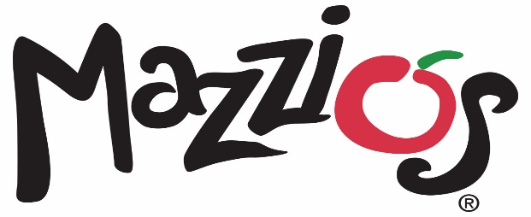

March 15, 2021

Contact: Kristy White (918) 638-0686

**Mazzio’s Introduces its new 18-inch NY Giant Pizza**

TULSA, Okla. – Mazzio’s is introducing its new 18-inch NY Giant pizza, featuring five new specialty options, on March 15 at participating Mazzio’s locations.

Mazzio’s NY Giant pizza is loaded with mozzarella and provolone cheese and topped with a savory garlic and basil sauce. It is available with one topping for $12.99 or as one of five specialty options for $16.99 each.

The new specialty pizzas include:

* The Meathead
* Bronx Combo
* The Garden
* The Brooklyn Deli
* The Lady Liberty

“New York Style pizza is the most popular in America and we wanted to give our guests the opportunity to enjoy that flavor,” said Stuart Myers, vice president of marketing and sales of Mazzio’s LLC. “Just like New York, the NY Giant is big. And what better way to eat all the goodness than ‘fold it to hold it’? With all these specialty options, there’s a flavor for everyone.”

###

**About Mazzio’s LLC**

With 116 restaurants in 9 states, Tulsa-based Mazzio’s LLC was established in 1961 and is the parent company of the Mazzio’s Italian Eatery and Oliveto Italian Bistro brands. The corporation was founded in Tulsa, Oklahoma by the late Ken Selby and ownership remains in his family today.

Mazzio’s Italian Eatery’s 119 locations offer expedited service, convenience and great value in a fast casual setting. The family-friendly menu features Mazzio’s signature fresh salad bar and world-famous Ranch dressing, signature pizza, pastas, hot sandwiches, Wing Run® Wings and Calzone Rings® available for lunch and dinner, making it a perfect choice for dine-in, carryout, delivery, or large groups and catering.

To view our full menu, order online or get more information about Mazzio’s Italian Eatery, visit www.mazzios.com. Or download the Mazzio’s mobile app and enjoy ordering “on the go.”