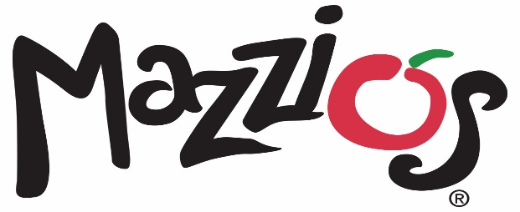

November 8, 2021

Contact: Kristy White (918) 638-0686

**Mazzio’s Honors Military with Veterans Day Special November 11**

Tulsa, Okla. - Mazzio’s is offering a lunch special to all veterans and active military personnel on Veterans Day, Thursday, Nov. 11.

Veterans and active military personnel can dine in at participating Mazzio’s locations and receive a free lunch buffet and soft drink. If the location does not have a lunch buffet, veterans will receive a free small one-topping pizza, salad bar and soft drink. Simply show your military ID to redeem this offer. Offer is only available for dine-in service.

“We are so thankful for all the veterans who have or are currently serving our country,” said Eric Selby, vice president of Mazzio’s LLC. “We appreciate all they do, and as a small thank-you we hope they will enjoy lunch on us.”

###

**About Mazzio’s LLC**

With 116 restaurants in 9 states, Tulsa-based Mazzio’s LLC was established in 1961 and is the parent company of the Mazzio’s Italian Eatery and Oliveto Italian Bistro brands. The corporation was founded in Tulsa, Oklahoma by the late Ken Selby and ownership remains in his family today.

Mazzio’s Italian Eatery’s 119 locations offer expedited service, convenience and great value in a fast casual setting. The family-friendly menu features Mazzio’s signature fresh salad bar and world-famous Ranch dressing, signature pizza, pastas, hot sandwiches, Wing Run® Wings and Calzone Rings® available for lunch and dinner, making it a perfect choice for dine-in, carryout, delivery, or large groups and catering.

To view our full menu, order online or get more information about Mazzio’s Italian Eatery, visit www.mazzios.com. Or download the Mazzio’s mobile app and enjoy ordering “on the go.”